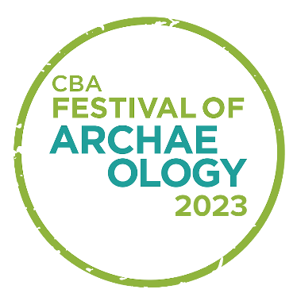
Image Permission Form
Event title and organiser:

Video and photographs may be taken during today’s CBA Festival of Archaeology event. The CBA would like your permission to use any images or video recorded that may include a child under 13 in your care to promote the festival online, across social media or in printed materials.
The CBA have strict rules on the use of images, and we will never publish personal information about your child with their images without your express permission.
Any images taken at the event will be kept securely and may be used at any time in the future.
If you have any questions about how we use images, please contact CBA staff using the details below.

Parent/carer’s name:
Parent/carer’s signature:
Child’s name:
Child’s signature:
Date:

