Gods, Heroes, Monsters and Playmobil at the National Roman Legion Museum

From a young age I have always had a fascination with Graeco-Roman and other mythologies. Stories of gods, monsters and heroes really grab my imagination. This probably started from watching movies like Jason and the Argonauts and Clash of the Titans with my parents, reading books and eventually going to university where I was lucky enough to study some of the ancient texts such as the Iliad and the Odyssey (I’m very excited for the upcoming movie, despite some dubious costumes!).
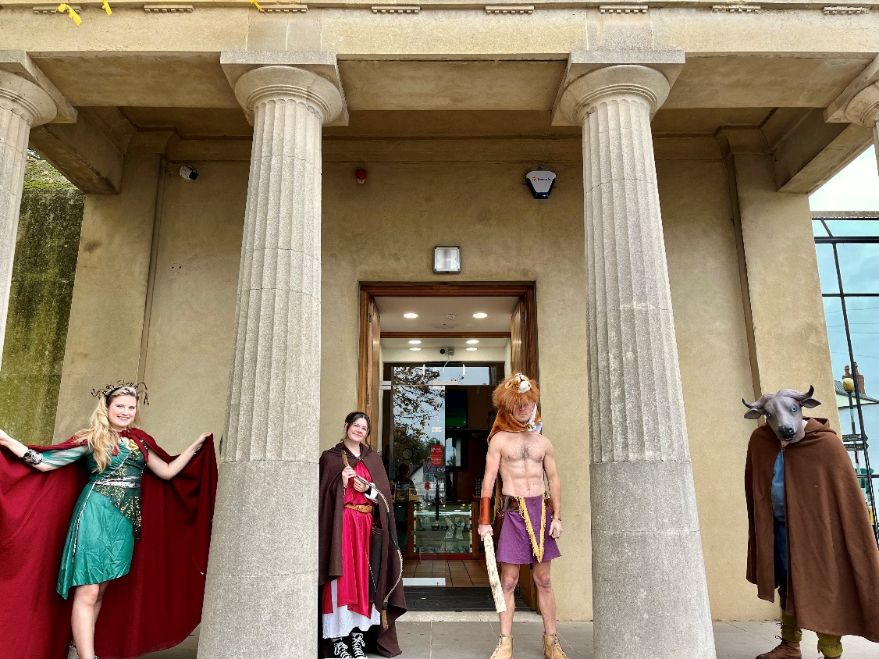
When I started work at the National Roman Legion Museum 14 years ago I very quickly got to notice just how many amazing artefacts we have in the collection that feature these mythological characters, that for many of the Romans and Greeks were very real. Over the years I have used these objects to deliver storytelling activities and events such as our activity trail ‘Become a Hero.’ In this event our visitors are given questions to answer around the gallery and museum before taking part in an obstacle course, archery, escaping the Minotaur and fight training with various heroes such as Achilles, all guided by our staff members dressed as various characters.

Picture from our ‘Become a Hero’ event featuring Medusa, Diana, Hercules and the Minotaur

However, the piece of mythological work that I enjoyed the most began in the summer of 2022. Both of my young sons, Hector and Arthur, absolutely love playing with Playmobil figures (as do I) and Playmobil had started to bring out a mythological range of figures featuring the 12 Olympian Greek gods and scenes from the Iliad, Odyssey and Jason and the Argonauts.
After obviously buying some for my children () I thought perhaps it would be a good idea to get some in for the museum. Around this time, I had also been thoroughly enjoying the very interesting and fun analysis of the figures compared to the actual descriptions of the Greek gods by the brilliant Laura Jenkinson-Brown. (if you haven’t seen it check out the thread on X Greek Myth Comix on X: "✨And now, my Playmobil Olympians collection is complete*! ✨ *Hades is not included and Dionysus was only available with the Olympis playset 🤔 https://t.co/PRzg2rGvUe" / X )
This, coupled with the beautiful objects at our museum, gave me the idea of adapting the figures Playmobil already produced to make Roman versions of them and create an activity for our visitors to find the objects that fit with the figures. Many of the objects are very small and easily missed so I thought this would be a great way of highlighting them. Beginning with the base versions of each character I used old spare parts I already had, the Playmobil website bits service and a very useful Spanish company Playmoingstore | Loose Playmobil Parts, Figures & Collectibles at Playmobil online store | Nearly 10K References to attempt to recreate some of the figures on our museum objects. Some of these will be shown below:

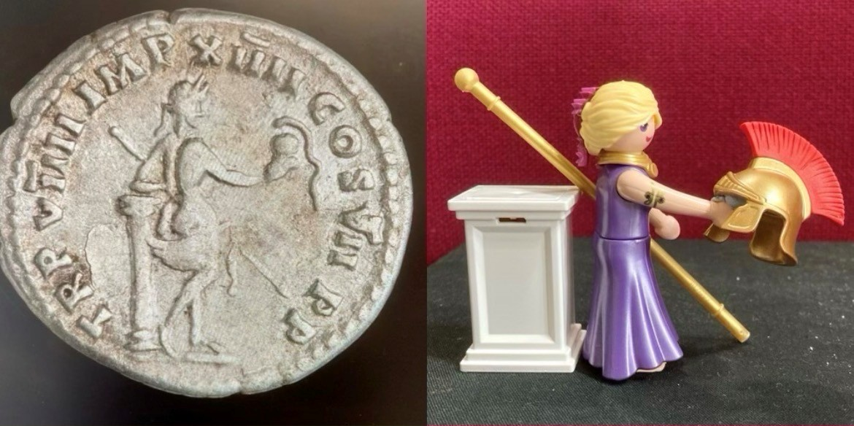

Here we have the goddess of seduction and love, Venus. She features on many objects at our museum as she was believed to be an ancestress of the Emperor Augustus and so she was seen as a protectress of Legio II Augusta. To recreate her image on this silver denarius I added a helmet and the Playmobil sceptre of Zeus/Jupiter to the Playmobil figure of Aphrodite.

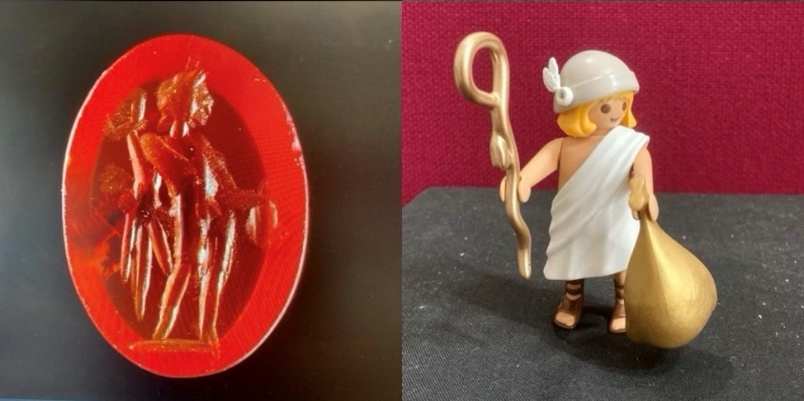

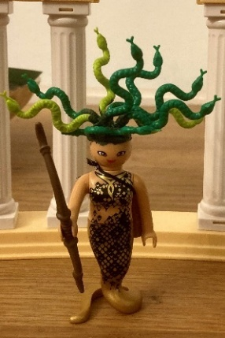
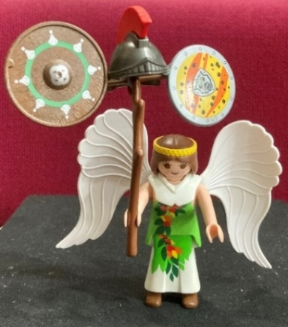
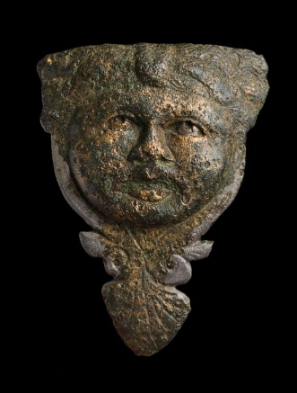
Here’s an Intaglio from the Fortress Baths. It depicts Mercury, god of circulation, the movement of goods, people, and words and their roles, who stands front and left. He holds a moneybag in his outstretched hand, and the caduceus staff in the other. Whilst I love the winged sandals on the original figure, Hermes is one of the poorer representations of the gods that Playmobil made. To keep him more in line with his Roman look I got rid of his silly winged crown and created a winged hat instead. I also swapped out the single snake staff (That’s the staff of Aesculapius) for the double snake staff you can see on the picture with some wings stuck on either side.
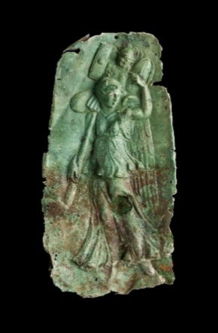
I created some of the Playmobil figures from scratch such as the goddess Victory, shown here carrying a trophy of arms on a bronze plaque and the terrifying gorgon Medusa. Medusa features on many objects at the museum as her image was believed to scare away evil. For this figure, I very much went down the Ray Harryhausen Clash of the Titans look, using a base figure of the Playmobil snakewoman complete with Lego snake hair.

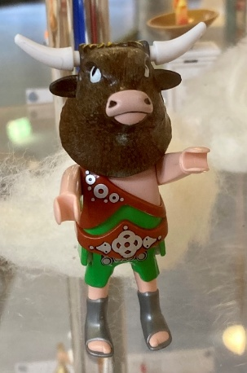
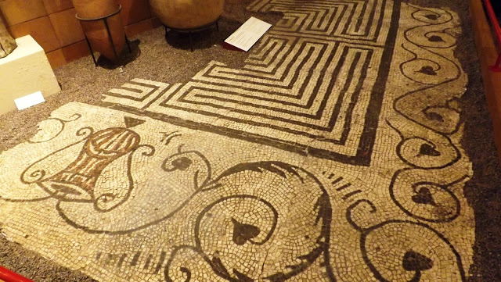

The bull-headed Minotaur, who may have featured in the centre of our Labyrinth mosaic, was another favourite I got to make. I achieved this by sticking a Bulls head trophy from the House of Vitalstatistix onto an old Playmobil gladiator we had at the museum.
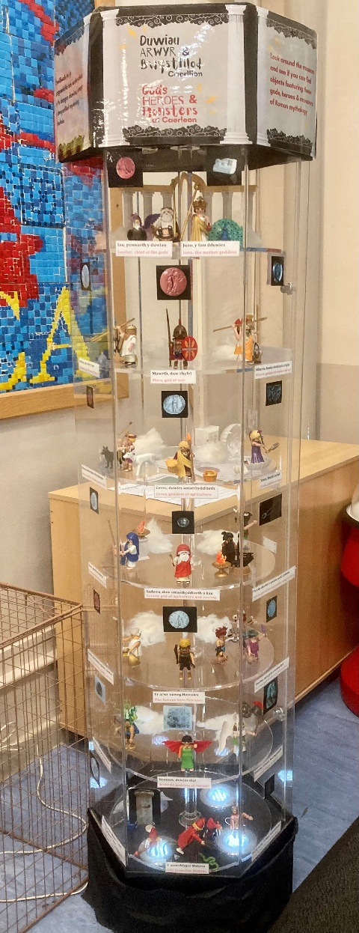
Once I had gathered all the gods, heroes and monsters together I needed to find a way to put them on display. Thankfully, we had an old perfume and oil lamp display case that the shop was no longer using, so I quickly repurposed that as a home for our characters.
Following this, I worked with our fantastic Digital Officer, Kat, to make an online version of our resource so people could also enjoy looking at the figures and their archaeological objects from the comfort of their own homes. This can be found here:
Roman Mythology: Gods, Heroes, & Monsters | Museum Wales
We even had a go at telling the story of the Fall of Phaeton through some stop start animation, which you can take a look at here The Fall of Phaeton...or how the Milky Way was made (according to Greco-Roman mythology) - YouTube

As the theme for this year’s Festival of Archaeology is ‘Nature and Archaeology’ it only makes sense to particularly show off the Playmobil gods and objects that have animals associated with them.

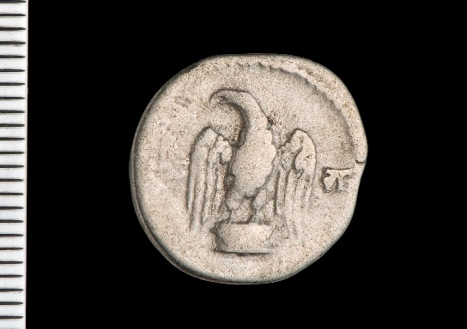
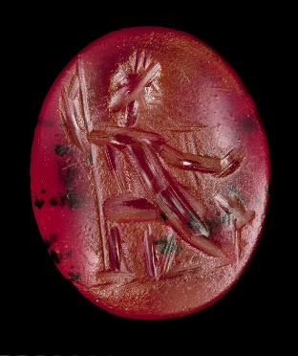
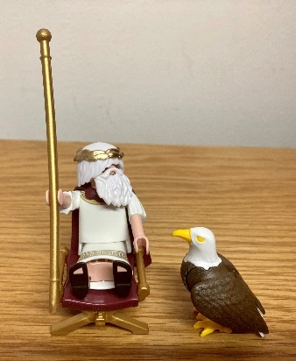

The King of the gods himself, Jupiter, shown here on this Intaglio from the Fortress Baths. He sits on a throne, carrying a sceptre of power with his majestic eagle companion at his feet. Jupiter’s sacred eagle also features on this denarius issued during the reign of the Emperor Vespasian. Zeus/Jupiter was one of the figures I actually didn’t have to change at all.
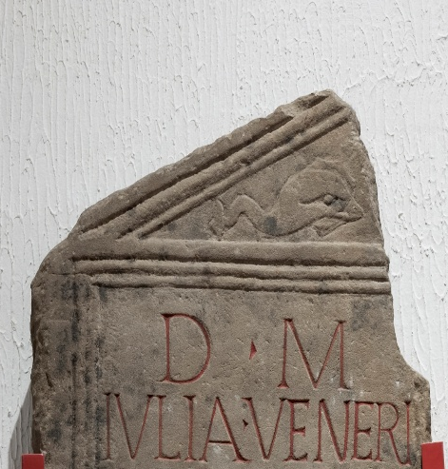
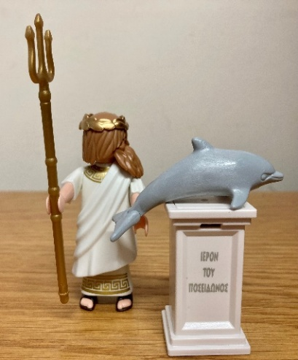
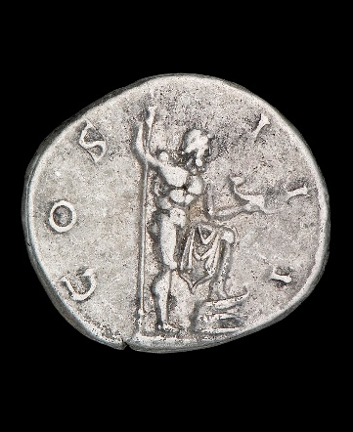

Neptune, god of the sea, is depicted on this silver denarius. He holds his trident in one hand and a dolphin in the other. Dolphins appear on a number of objects in Caerleon, including the gravestone of Julia Veneria. The Romans and Greeks believed that dolphins took the souls of the dead to the afterlife.

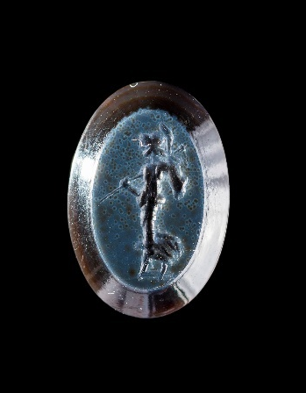
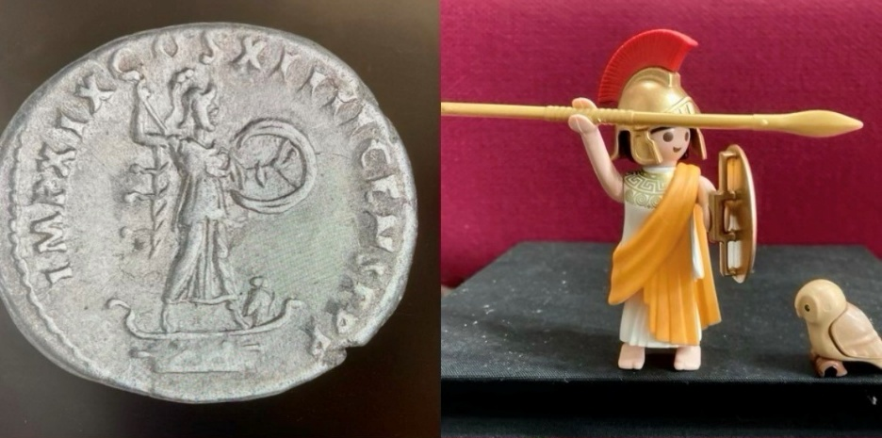

Minerva, the goddess of craftmanship, wisdom and war is shown on this silver denarius and Intaglio from our collection. Like Jupiter and Neptune, this was another figure I didn’t need to change. Minerva even came with her owl (a symbol of wisdom and cleverness) which can be seen on the coin at her feet.
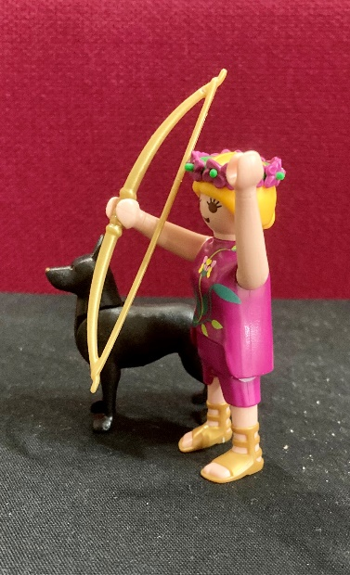
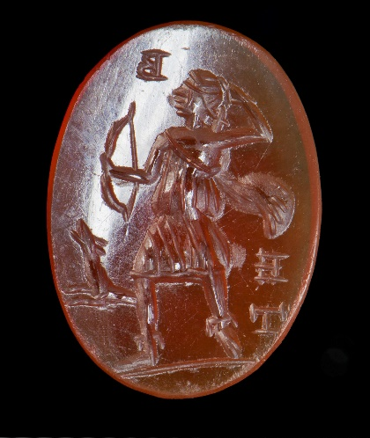

Here we have an Intaglio featuring, Diana, goddess of the hunt, women, children, childbirth, slaves, and asylum. She was originally a moon goddess. She is shown here running with bow in hand alongside her hound dog hunting companion.

Since making the Gods, Heroes and Monsters of Caerleon display I have continued to look at ways I can use Playmobil figures to bring archaeology, history and mythology alive for our audience both in person and online. I’ve created a barracks for our Playmobil legionaries, gladiators that look more authentic than the standard figures, iron age Britons and recreated other scenes of myth and history. Below are a selection of them.
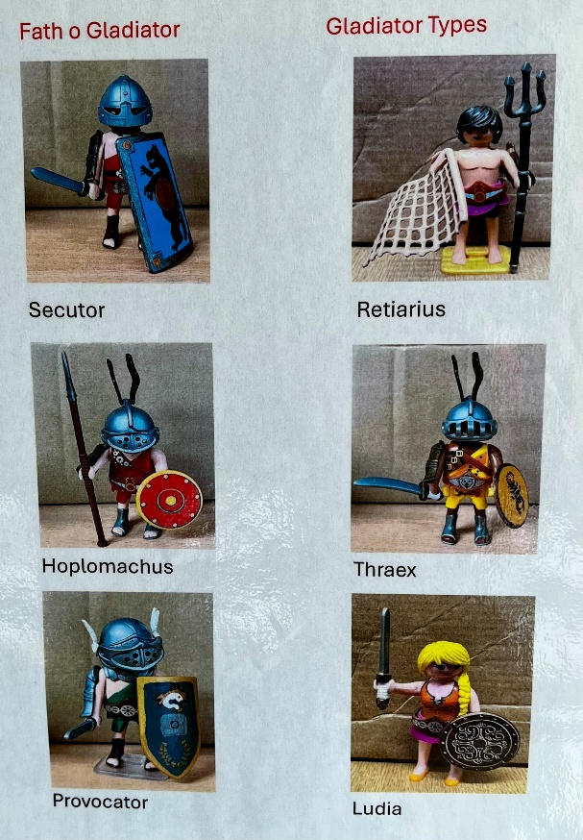
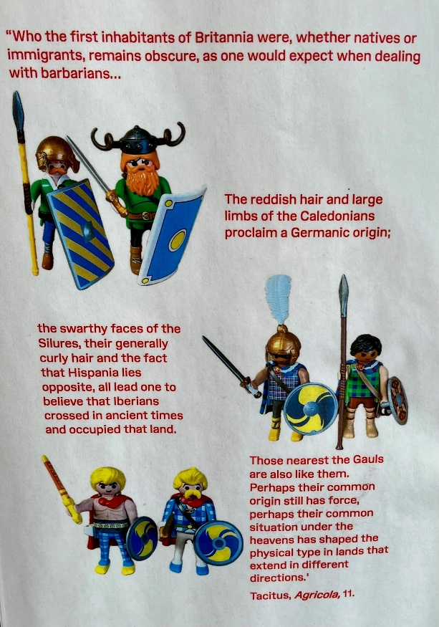

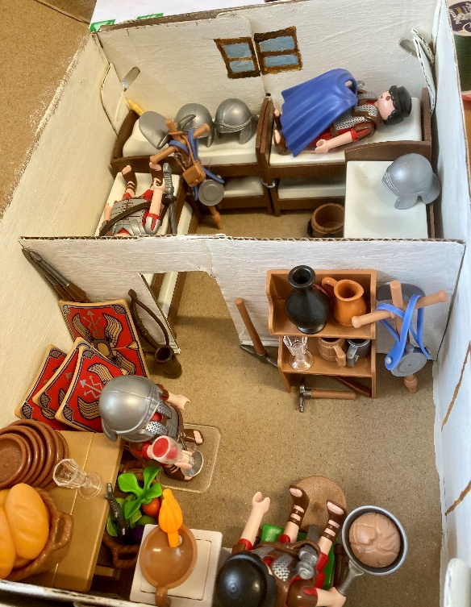
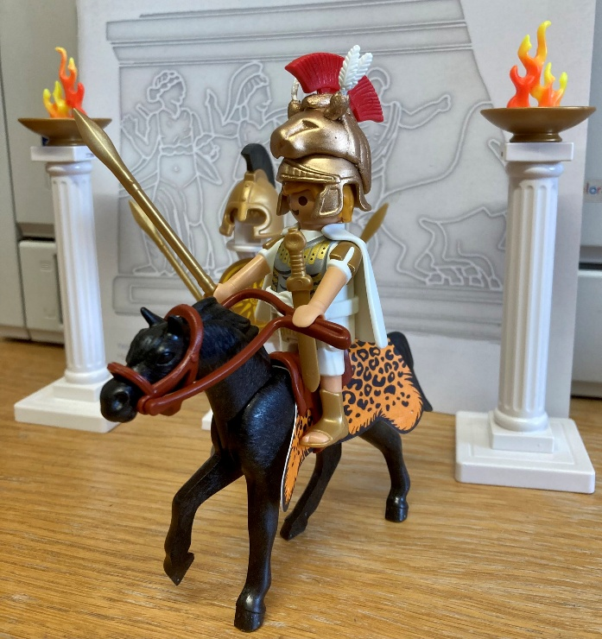
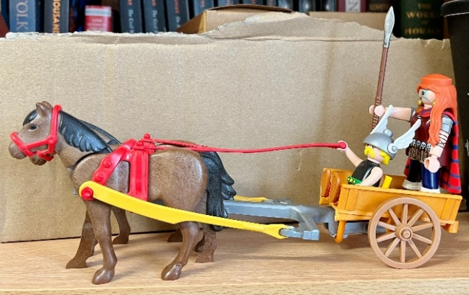
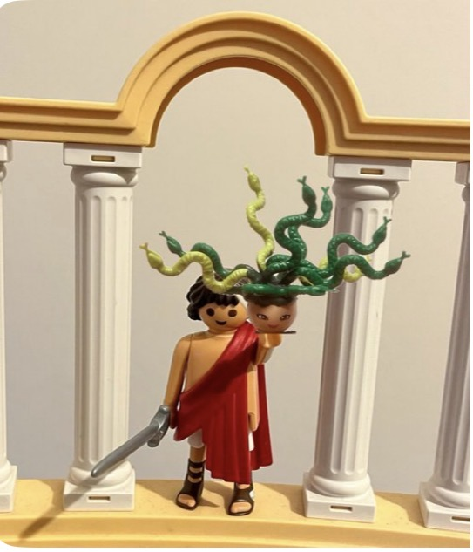
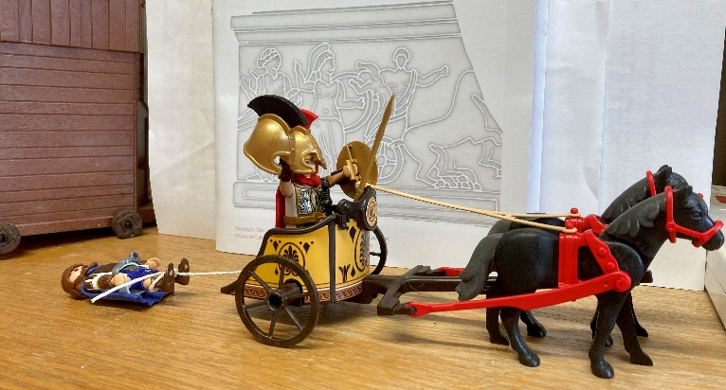
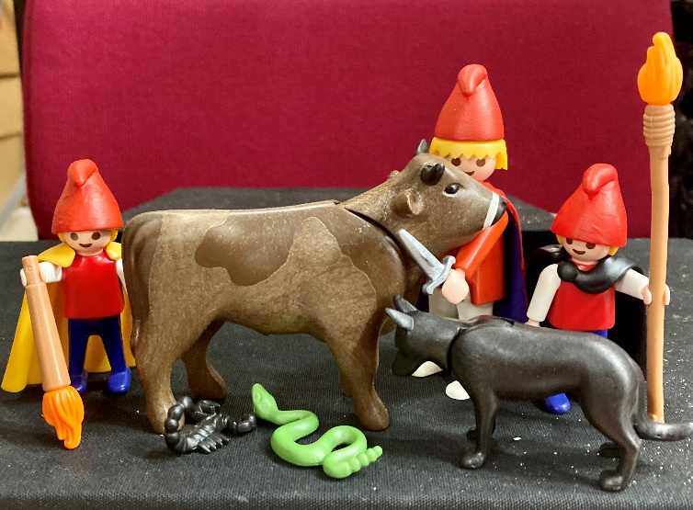
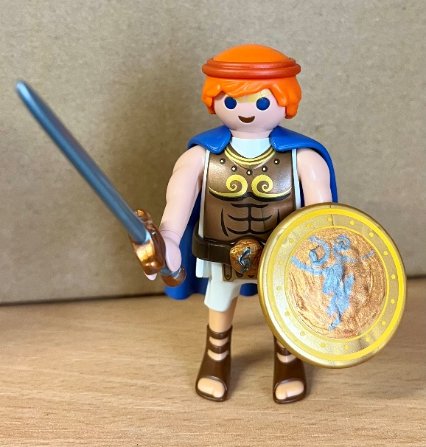
Can you guess who any of these are? (Answers at the bottom)

Answers from top to bottom, left to right: Disney’s Hercules; The Roman god Mithras and his torchbearers, Cautes and Cautopates; Boudica in her chariot; Achilles dragging the body of Hector; Perseus with the head of Medusa (heavily inspired by Clash of the Titans); Alexander the Great riding Bucephalus.

I hope you’ve enjoyed this Playmobil Odyssey, journeying through the gods, heroes and monsters of Roman Caerleon. Why not come along to the National Roman Legion Museum sometime and check out the rest of it? You could also keep with the Festival of Archaeology theme of Animals and Archaeology by checking out our Animals of the Gods temporary exhibition which runs until 25th July!
Before I go, I have to signpost another brilliant Playmobil creator! Duncan Mackay created some incredibly fun and engaging archaeological and historical social media posts using Playmobil under the hashtag #playmobilinfestation. If you haven’t seen his Playmobil Ötzi, the Iceman, you really need to. It’s phenomenal!

