**FoJW /CBA Yorkshire**

**Joint Archaeological Site Visit**

**Judy Woods Cottage Wyke Bradford**

**Saturday, June 3rd 10.00 a.m.**

**Everyone Welcome**

**Access**

**As the woods are open access, it isn’t necessary to prebook your attendance with FoJW.**

**Parking is available adjacent to the site with additional parking generously provided by the Pear Tree Pub (HX3 8QD) 100m above and to the left of the site entry. The postcode above offers the best sat. nav. location. For information on other transport arrangements, please visit the website shown below.**



**Note Access to a QR Code reader will be particularly useful for this visit that reviews the regeneration of Judy North’s 19th Century Market Garden and the extensive archaeological site survey and excavation. See Geo/Phys results overleaf.**

**Visit our website** [**www.judywoods.org.uk**](http://www.judywoods.org.uk) **or** [**info@judywoods.org.uk**](mailto:info@judywoods.org.uk)

**Geo/Phys Survey Details 2005 (amended)**

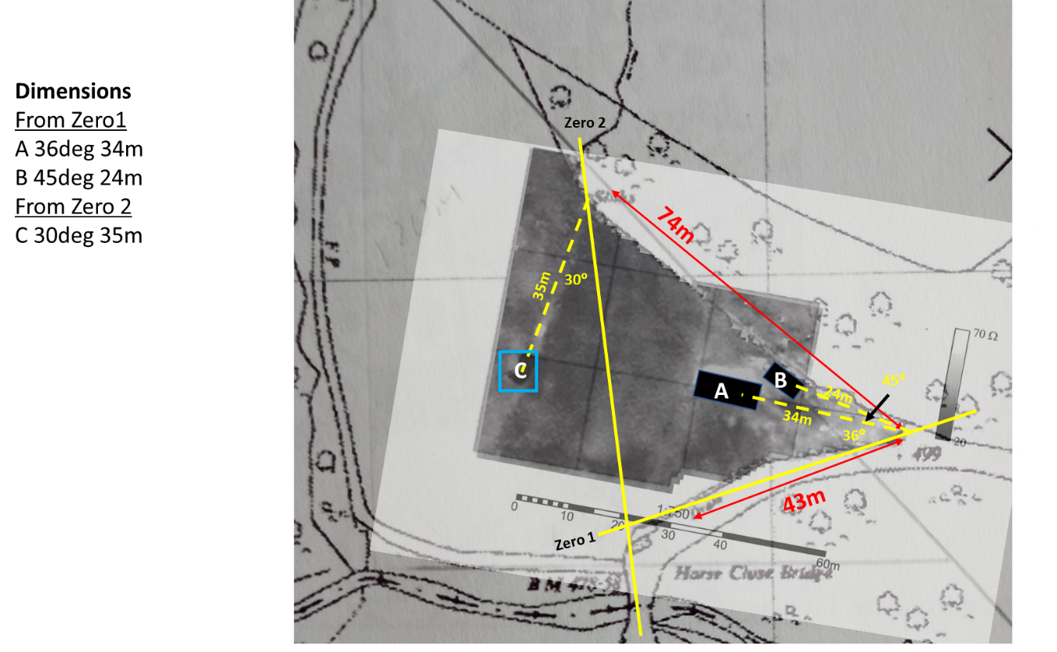

**Interpretation of original fluxgate gradiometer (Horsley 2005)**

**2023 Re-evaluation of 2005 results and proposed survey site location**

**Comparison 1854 OS Survey and interpretation of geo/phys survey (Horsley 2005)**

