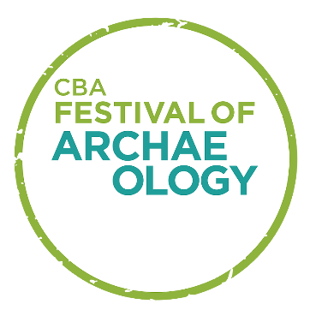
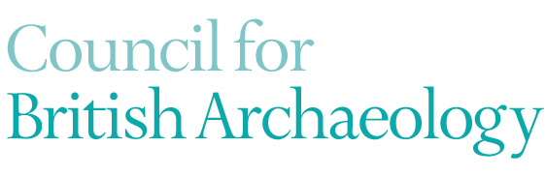
CBA Festival of Archaeology – Resources Volunteer
Role description
The CBA Festival of Archaeology is the UK’s largest celebration of archaeology, and in 2022 we will host the 31st Festival from 16-31 July. The Festival is co-ordinated by the CBA and made possible by the collaboration of event organisers, large and small. These range from community archaeology groups and individuals to museum services and national organisations. In 2022 we expect there to be around 1,000 Festival events reaching a quarter of a million people.
As a Festival Resources volunteer, you will be helping to transfer our library of 214 resources from our old website onto the new website. We will also be assessing the previously submitted resources for their suitability for the new website, this includes checking whether the web links are still valid and corresponding with the Resource author to update the information. You will also be moderating new resources as they are added and looking for and approaching (with guidance/prepared text) organisations that may have existing resources are be interested in creating one. In return, you will get the chance to develop your IT and communication skills, learn about the work of a UK-wide charity and develop your passion and interest in archaeology and heritage.
The Council for British Archaeology is an independent educational charity working to promote our vision of ‘archaeology for all’ where everyone has the opportunity to participate in, and care for, the historic environment. We are a membership organisation and have around 6,500 members and subscribers who also receive our magazine, British Archaeology.
We work alongside volunteers in a number of different ways – both at our offices in York and through our projects, such as the UK-wide network of Young Archaeologists’ Clubs and through involvement with our regional network of CBA groups.
Title | Festival of Archaeology – Resource Volunteer, Council for British Archaeology
Main tasks | - Uploading resources on the Festival Website  - Checking accuracy and relevance of Resources  - Corresponding with Resource authors  - Feeding back on your work.
Hours/frequency | We ask you to commit a minimum of 2 hours per week from May to the end of July 2022.
Where | Volunteering will be carried out remotely  If working remotely we would ask you to join online on a regular basis for team meetings.
Skills and interests | - A good knowledge of at IT  - Friendly and enthusiastic  - Enjoy communicating  - Enjoy being part of a team  - Have an interest in archaeology and/or heritage  - Willingness to learn new skills
Training given | - The work of the Council for British Archaeology  - Effective communication  - Using the reviewing area of the Festival website  - Creating social media and blog content
Outcomes and Benefits | - Gain an insight into how a charity works  - Build communications skills  - Help to increase access to the Council for British Archaeology  - Meet new people across our networks  - Free one year student membership  - Opportunities to attend Festival events

To apply for this role please use our application form and return it to Debbie Frearson, Festival Coordinator at the Council for British Archaeology at debbiefrearson@archaeologyuk.org.
Deadline is 5pm on Friday 15 April 2022.
We may invite you in for a short informal interview online. This will take place sometime in the week beginning Monday 25 April 2022.

