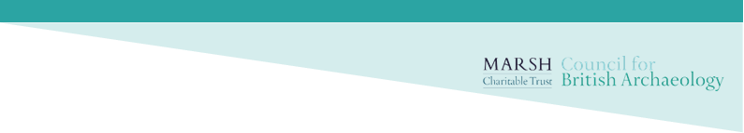

Community Archaeologist of the Year 2025
Nomination form

- Name of the nominated individual:
Their details
- Name:
- Email:
- Telephone:
- Address:

- Is the individual aware of the nomination? Yes / No

- Name and contact information of the person nominating:
Your details
- Name:
- Email:
- Telephone:
- Address:

- Would you like the identity of those nominating to be kept anonymous? Yes / No

- Please tell us in no more than 500 words why they deserve the award and how they meet one or more of the following criteria:
- The winner will have inspired others to get involved in archaeology
- The winner will have helped others to develop skills and knowledge in archaeology
- The winner will have broken down barriers to participation in archaeology
Text can include website and video links, and other content.

- If the nominee is entering themselves, please include a testimonial of no more than 500 words from someone else who knows them and their work, for example an archaeologist or fellow volunteer.

- Accompanying material:
Please submit a minimum of 1 and a maximum of 5 high resolution (1-2MB) images to support the nomination and for use in publicity of the Awards.
- Please provide an image description and details of who to credit for each image here:

- Please provide details of any relevant social media channels or websites here:

- Authorisation:
☐ I confirm that I have read the Nomination Guidance document (available here) and that the nominated individual meets the eligibility criteria.

☐ I confirm that the image(s) supplied with this application can be used by the CBA for promotion of the Marsh Community Archaeological Awards.

The deadline for applications is 12 noon on Monday 26 May 2025.
Completed nominations should be sent to awards@archaeologyuk.org

